CAS PY 106

Lecture Note 22

1. Review: sound
2. Speed of sound waves determined by the medium – cannot be changed
3. For example, if you choose to use a speaker vibrating at 600Hz in a room filled with air, then you’ll get a wave with a speed of 343m/s and wavelength of 0.57 meters
4. V = f \* lambda
5. V is defined by the nature
6. Typically, you choose the vibration frequency f and then the wavelength lambda is fixed by this equation
7. Sound intensity:
8. Sound waves carry energy through a medium over time. This is defined as intensity:

I = P/A (Power/Area) = P / (4pir^2)

1. 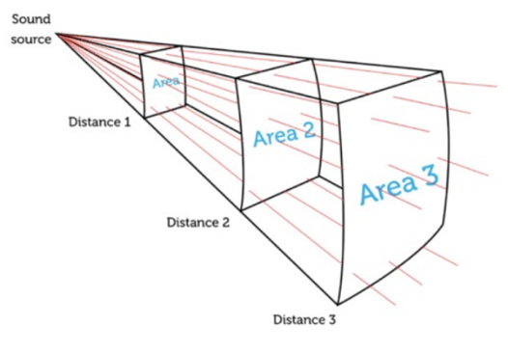
2. As you move away from the source of sound, the volume will decrease like 1/r^2
3. Sound intensity levels are typically measured in “decibels”:

B = 10\*log10(I/I0)

B = sound intensity in decibels dB

I = sound intensity in W/m^2

I0 = 10^-12 (W/m^2) = minimum intensity that a person can hear at a frequency of 1kHz

1. 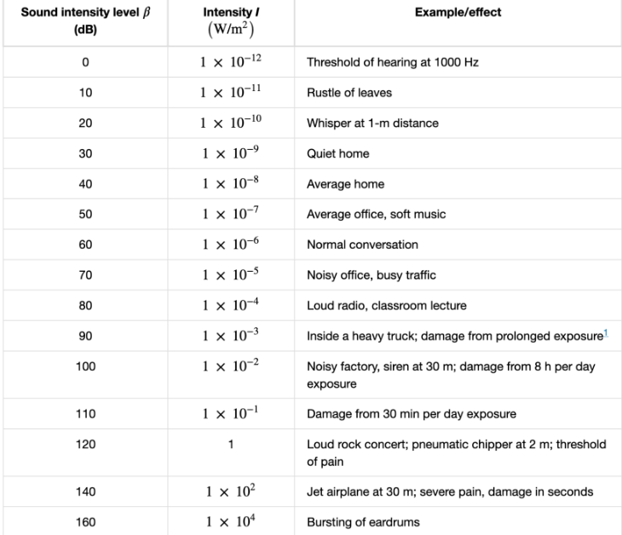
2. Doppler Effect: moving source
3. The Doppler effect is the shit in frequency of a wave that occurs when the wave source, or the observer/detector of the wave, is moving
4. 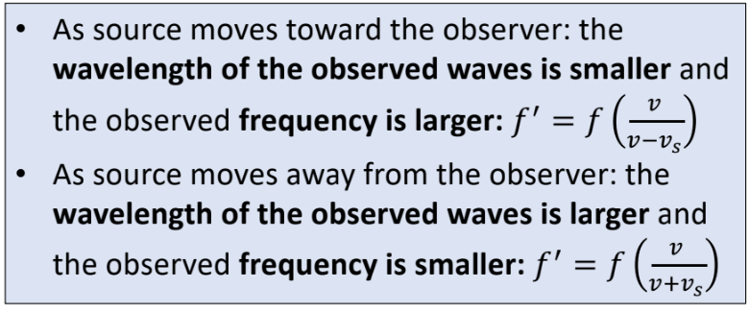
5. Important to note that the absolute speed of waves from the source remains constant
6. 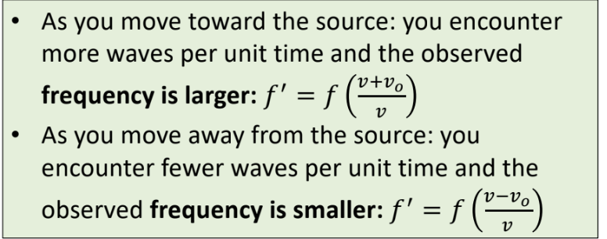
7. Wave interference
8. Notice how the waves move outward from their emission point to form concentric circles.
9. You can find spots in this image where the two waves are interfering with each other
10. Adding waves: superposition
11. When more than one wave is traveling in a medium, the waves simply add together
12. The principle of superposition: Net displacement of any point in the medium is the sum of the displacements due to each individual wave
13. 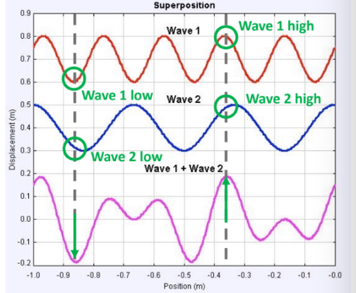
14. Constructive interference
15. When displacements of individual waves go in the same direction at a particular point on the wave, the result is an increasing magnitude of amplitude (this works with both waves upward or both waves downward)
16. After passing through one another, waves travel as if they had never met
17. Destructive interference
18. When the displacements of individual waves are in opposite directions at a point, the waves cancel (at least partially)
19. Superposition
20. Most sounds are combinations of waves at different frequencies
21. Time is along the x-axis
22. Frequency is along the y-axis and the colors represent the amplitude
23. 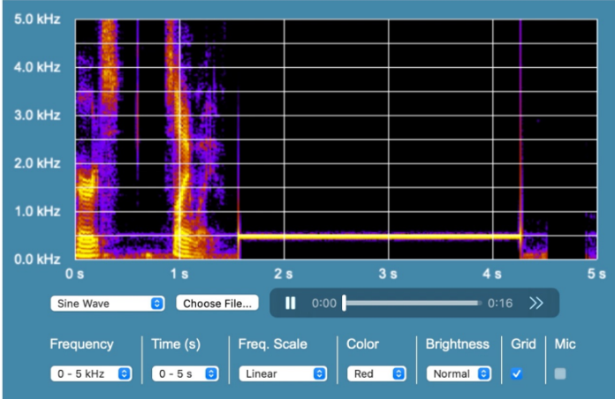
24. Beats
25. When you listen to two sound waves of similar frequency, you hear beats – the intensity of the sound rising and falling
26. When the waves are exactly in phase with one another, constructive interference produces a loud sound
27. Waves of different frequencies drift out of phase until destructive interference occurs and you hear nothing
28. Beats (continued)
29. 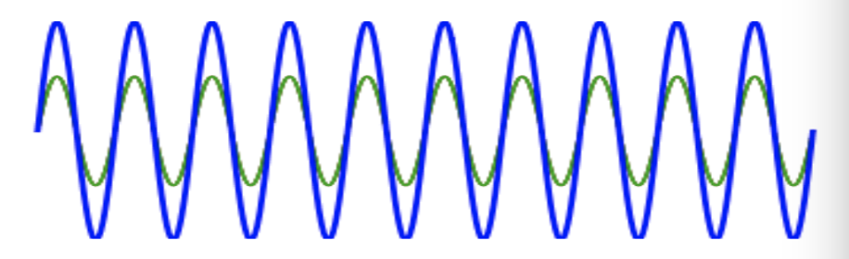
30. The red and green sources are initially sending out waves that are in phase, so they interfere constructively, preserving the shape of both but with greater magnitude
31. The frequency of the green wave is gradually increased and thus out of phase with the red wave
32. Because the frequencies are different the sources gradually drift out of phase, until eventually we get completely destructive interference
33. The sources continue to drift out of phase, but this actually moves us back towards constructive interference…and the cycle continues
34. Beats (continued)
35. 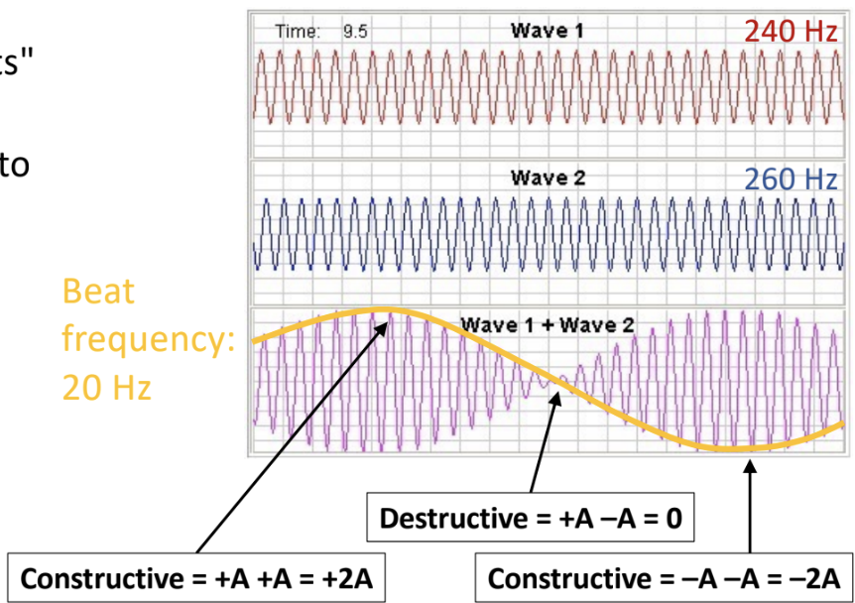
36. The intensity (loudness) of the sound oscillates from maximum to zero and back again continually. The closer the waves are in frequency, the slower the cycle of rising and falling intensity
37. The frequency of the rising and falling is known as beat frequency, which equals the difference in frequency between the two waves
38. What you hear are the “beats” (orange line)
39. With a beat frequency of 20Hz, you hear the rise and fall over period T = 1/fbeat = 50ms
40. If two waves are 0.05 Hz apart, you hear the rise and fall over a period of 1/0.05 = 20s